Solid Geometry - Types of Solids - Convexity Solids

Definition
# Source: AI Source: Provided by: [Data Path: Persons Table -> ID Column: 1, Name_En Column: Motasem Essam] -> From: [ChatGPT] on [7/25/2026]
Convexity Solids are three-dimensional geometric solids classified according to their convexity or non-convexity.
Convexity describes the geometric property of a solid based on whether every line segment connecting any two points inside or on the solid remains entirely inside or on the solid.
This classification divides solids into two fundamental categories:
- Convex Solids: Solids in which every line segment connecting any two points in the solid lies entirely within the solid.
- Non-Convex Solids (Concave Solids): Solids in which at least one line segment connecting two points in the solid passes outside the solid.
Convexity is a property of the entire solid, including its interior, rather than merely its external boundary.

Geometric Representation
# Source: AI Source: Provided by: [Data Path: Persons Table -> ID Column: 1, Name_En Column: Motasem Essam] -> From: [ChatGPT] on [7/25/2026]
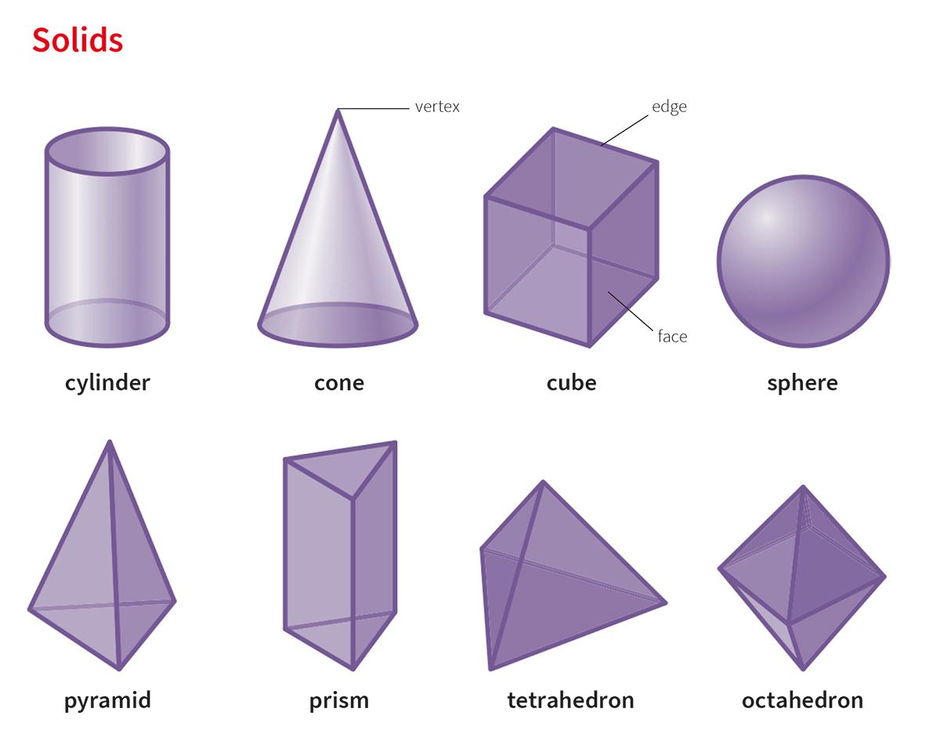
Convex Solids
No inward indentations or missing interior regions.
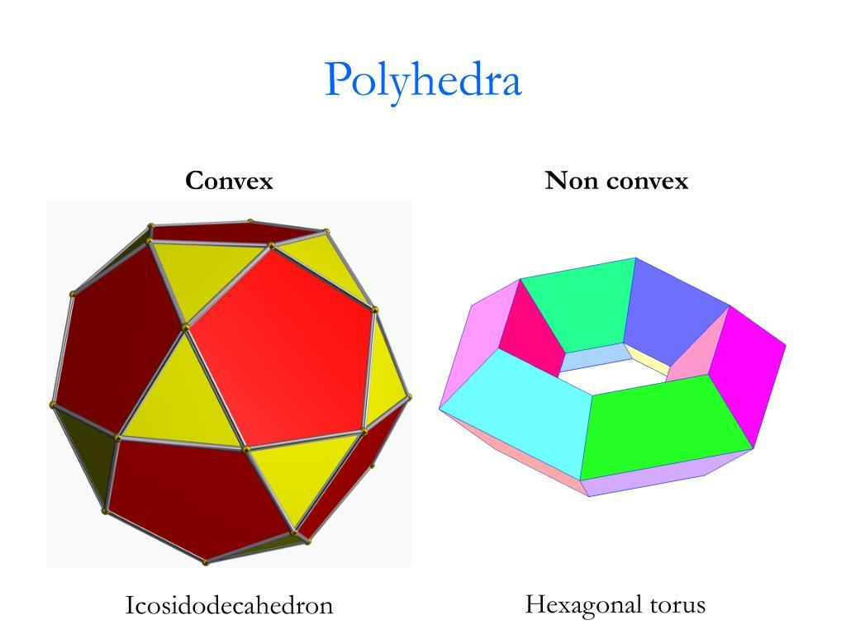
Non-Convex Solids
Contain indentations, tunnels, or other non-convex structures.

Classification of Convexity Solids
# Source: AI Source: Provided by: [Data Path: Persons Table -> ID Column: 1, Name_En Column: Motasem Essam] -> From: [ChatGPT] on [7/25/2026]
The classification consists of two main groups:

Convex Solids
# Source: AI Source: Provided by: [Data Path: Persons Table -> ID Column: 1, Name_En Column: Motasem Essam] -> From: [ChatGPT] on [7/25/2026]
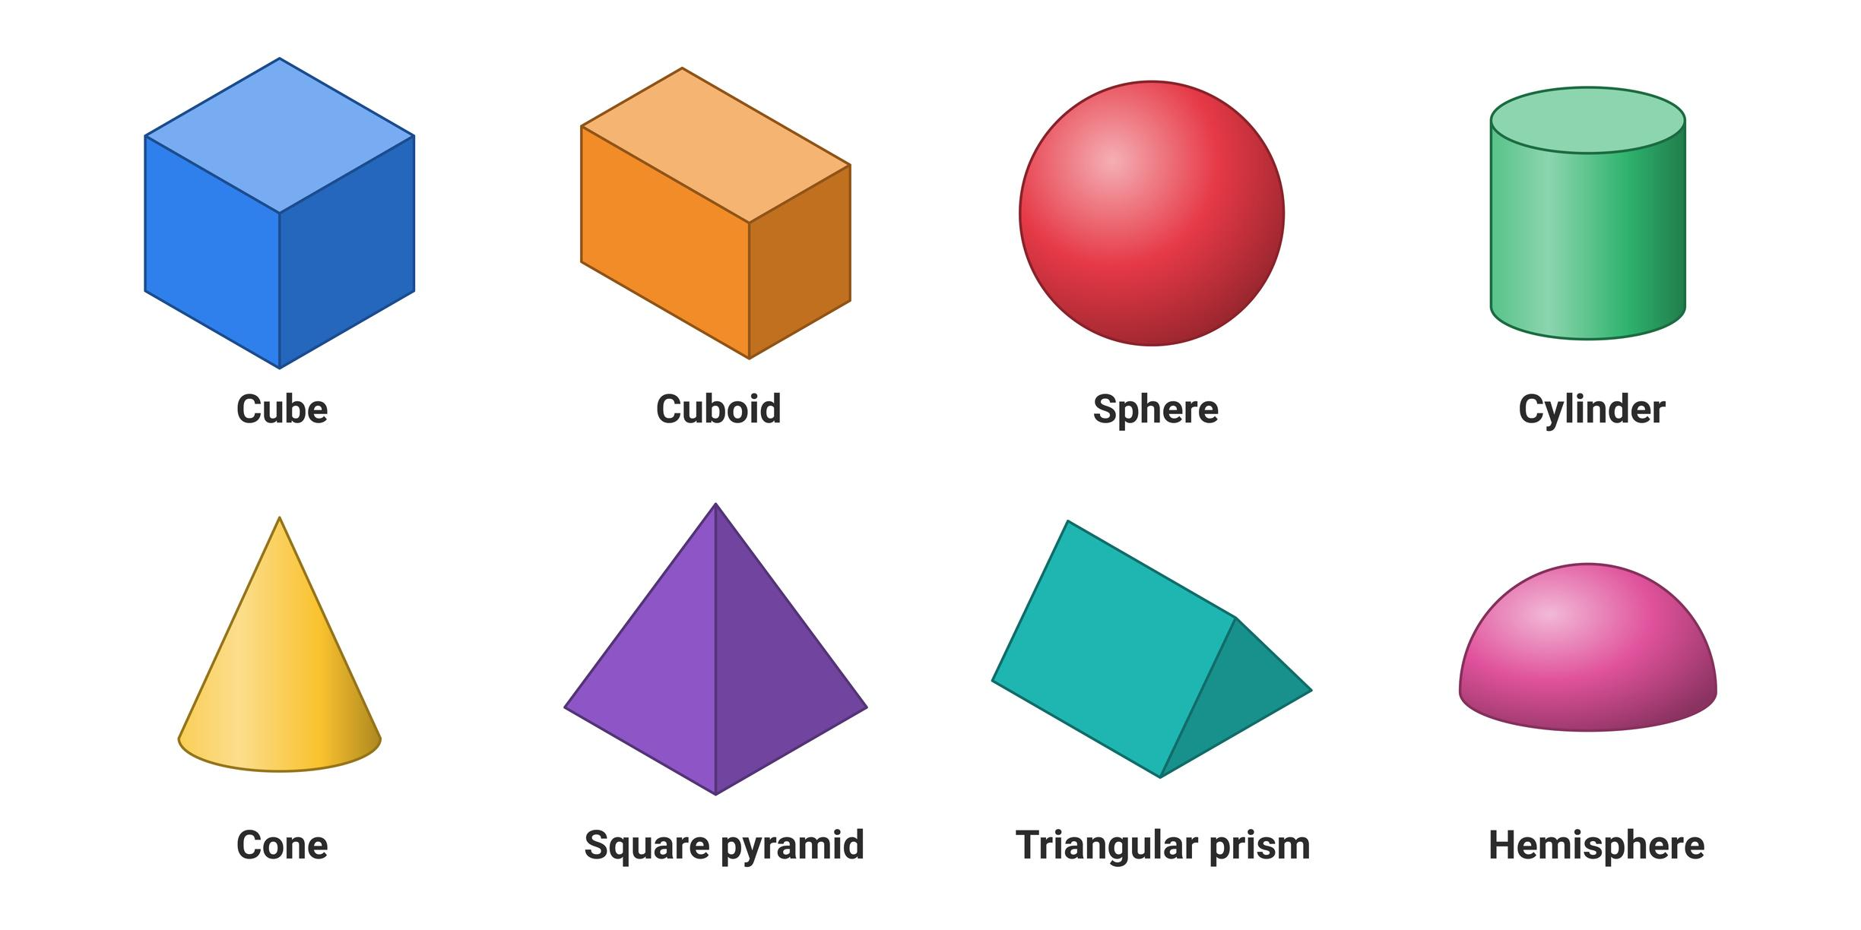
Solids satisfying the convexity condition.

Non-Convex Solids
# Source: AI Source: Provided by: [Data Path: Persons Table -> ID Column: 1, Name_En Column: Motasem Essam] -> From: [ChatGPT] on [7/25/2026]
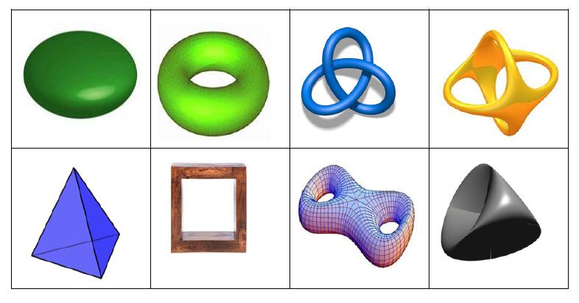
Solids that violate the convexity condition.

Convex Solids

Definition
# Source: AI Source: Provided by: [Data Path: Persons Table -> ID Column: 1, Name_En Column: Motasem Essam] -> From: [ChatGPT] on [7/25/2026]
Convex Solids are three-dimensional solids in which every line segment connecting any two points belonging to the solid lies entirely within the solid or on its boundary.
They have no inward indentations that cause connecting segments to pass outside the solid.

Geometric Characteristics
# Source: AI Source: Provided by: [Data Path: Persons Table -> ID Column: 1, Name_En Column: Motasem Essam] -> From: [ChatGPT] on [7/25/2026]
- Every segment connecting two points in the solid remains inside or on its boundary.
- They have no concave indentations.
- Their intersections with straight lines are connected intervals, points, or empty sets.
- Their planar cross-sections are convex figures.
- Their convex hull is the solid itself.

Types of Convex Solids
# Source: AI Source: Provided by: [Data Path: Persons Table -> ID Column: 1, Name_En Column: Motasem Essam] -> From: [ChatGPT] on [7/25/2026]
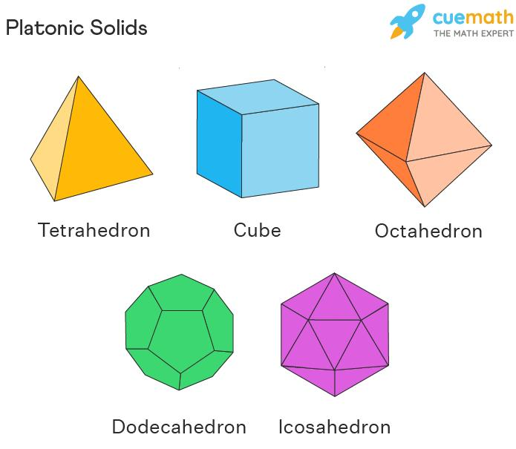
Convex Polyhedra
Platonic solids and other convex polyhedra.
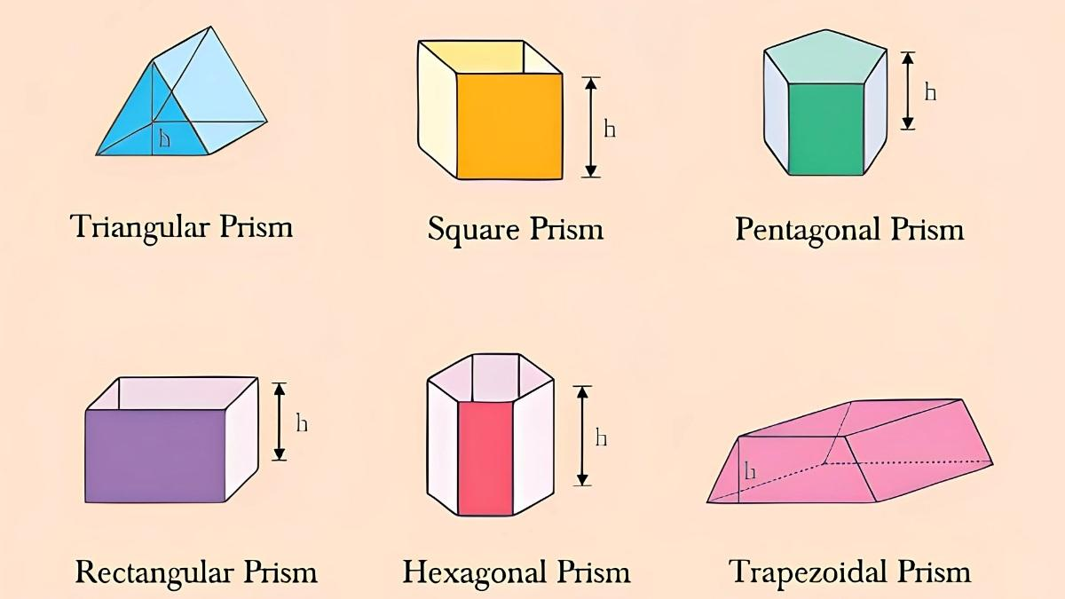
Convex Prisms
Prisms with convex polygonal bases.
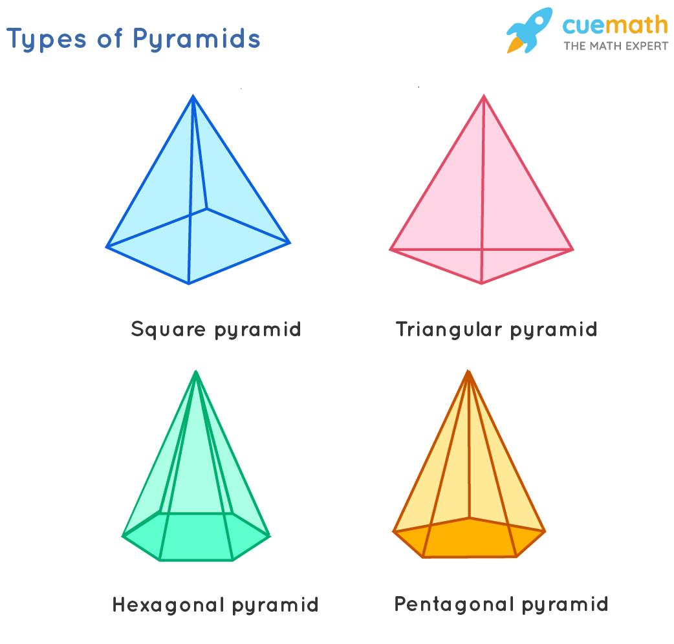
Convex Pyramids
Pyramids with convex polygonal bases.

Convex Curved Solids
Sphere, solid cylinder, and solid cone.

Examples
# Source: AI Source: Provided by: [Data Path: Persons Table -> ID Column: 1, Name_En Column: Motasem Essam] -> From: [ChatGPT] on [7/25/2026]
- Cube
- Regular Tetrahedron
- Regular Octahedron
- Regular Dodecahedron
- Regular Icosahedron
- Convex Prisms
- Convex Pyramids
- Solid Sphere
- Solid Cylinder
- Solid Cone
- Solid Ellipsoid

Non-Convex Solids

Definition
# Source: AI Source: Provided by: [Data Path: Persons Table -> ID Column: 1, Name_En Column: Motasem Essam] -> From: [ChatGPT] on [7/25/2026]
Non-Convex Solids, also called Concave Solids, are three-dimensional solids in which at least one line segment connecting two points belonging to the solid passes partially or entirely outside the solid.
They may contain inward indentations, cavities, tunnels, or intersecting geometric structures.

Geometric Characteristics
# Source: AI Source: Provided by: [Data Path: Persons Table -> ID Column: 1, Name_En Column: Motasem Essam] -> From: [ChatGPT] on [7/25/2026]
- At least one connecting segment between two points in the solid leaves the solid.
- They may contain concave regions or inward indentations.
- Their cross-sections may be non-convex.
- Their convex hull is larger than the original solid.
- They may contain holes, tunnels, or self-intersecting boundaries, depending on their construction.

Types of Non-Convex Solids
# Source: AI Source: Provided by: [Data Path: Persons Table -> ID Column: 1, Name_En Column: Motasem Essam] -> From: [ChatGPT] on [7/25/2026]
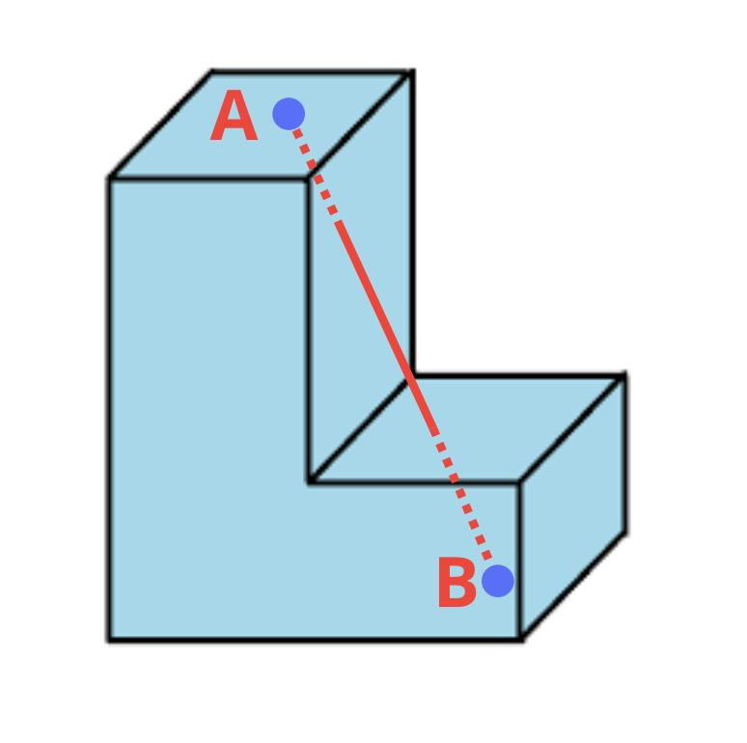
Concave Polyhedra
Polyhedra with inward indentations.
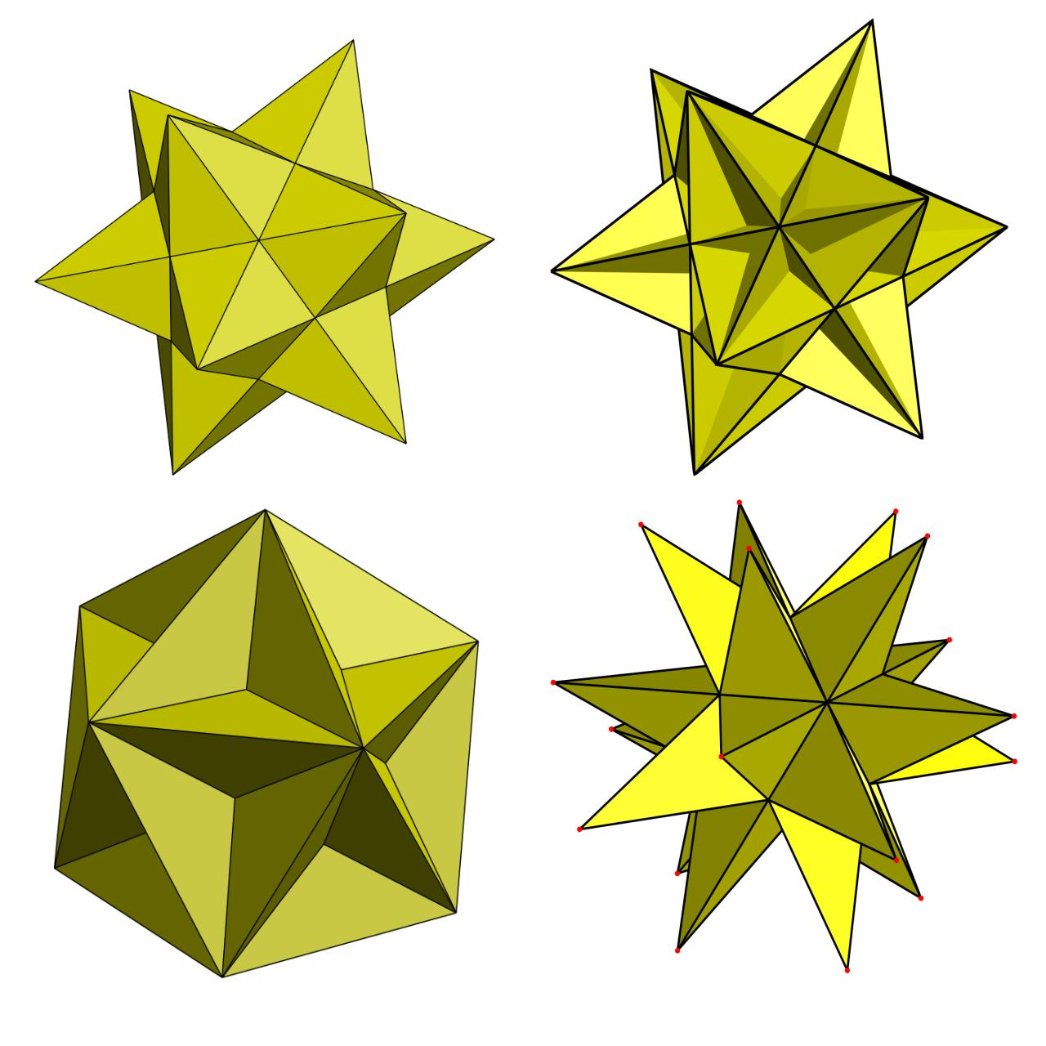
Star Polyhedra
Polyhedra with star-shaped or intersecting geometry.
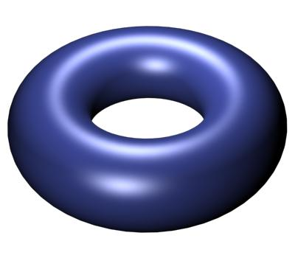
Torus Solids
Solids with a central tunnel.
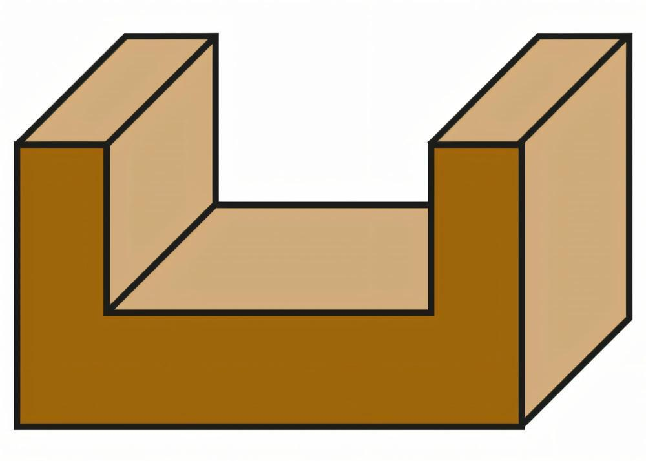
Concave Composite Solids
Combined solids forming inward indentations.

Examples
# Source: AI Source: Provided by: [Data Path: Persons Table -> ID Column: 1, Name_En Column: Motasem Essam] -> From: [ChatGPT] on [7/25/2026]
- L-Shaped Polyhedron
- Cross-Shaped Polyhedron
- Concave Prisms
- Concave Pyramidal Solids
- Small Stellated Dodecahedron
- Great Stellated Dodecahedron
- Great Dodecahedron
- Great Icosahedron
- Torus
- Spindle Torus
- Hollow Cylinder
- Hollow Sphere
- U-Shaped Composite Solid

Mathematical Definition
# Source: AI Source: Provided by: [Data Path: Persons Table -> ID Column: 1, Name_En Column: Motasem Essam] -> From: [ChatGPT] on [7/25/2026]
A solid $S$ is convex if, for every pair of points $P,Q∈S$, every point on the line segment joining them also belongs to $S$.
Mathematically:
$$\boxed{(1-t)P+tQ∈S}$$
for all:
$$P,Q∈S, 0≤t≤1$$
If this condition fails for even one pair of points, the solid is non-convex.

Convexity Test
# Source: AI Source: Provided by: [Data Path: Persons Table -> ID Column: 1, Name_En Column: Motasem Essam] -> From: [ChatGPT] on [7/25/2026]
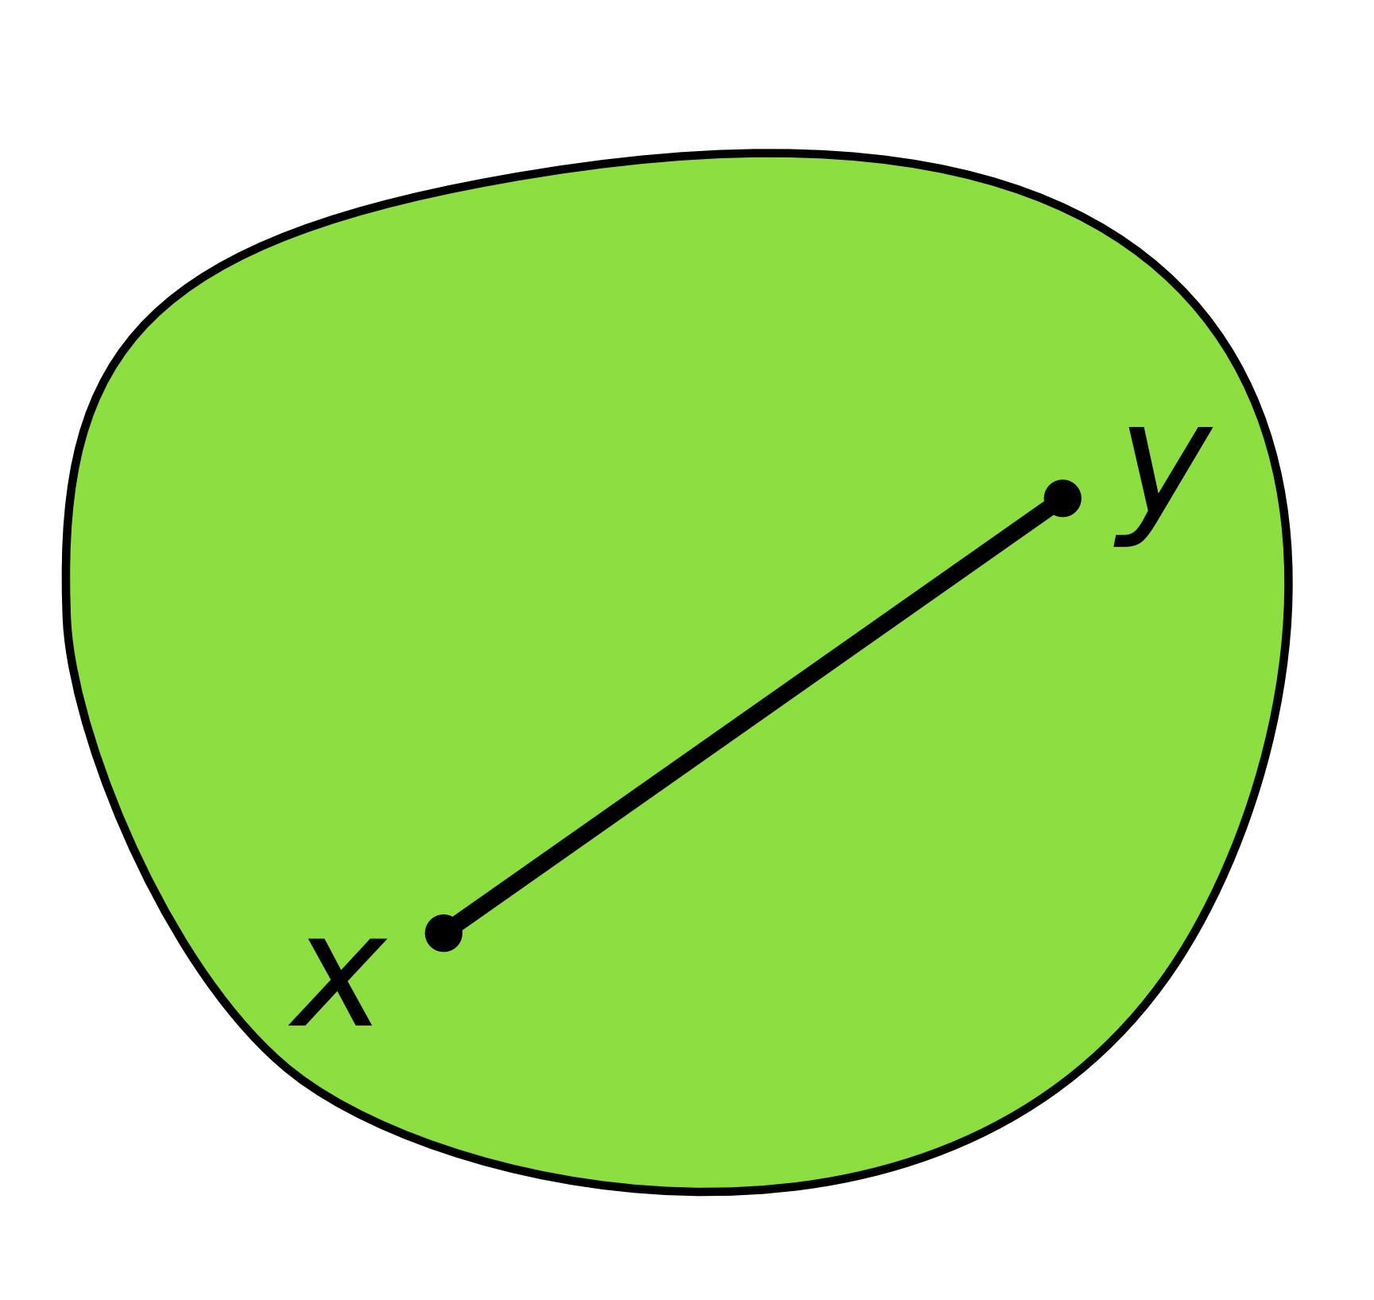
Convex Solid
Passes test
Every connecting segment stays inside or on the solid.
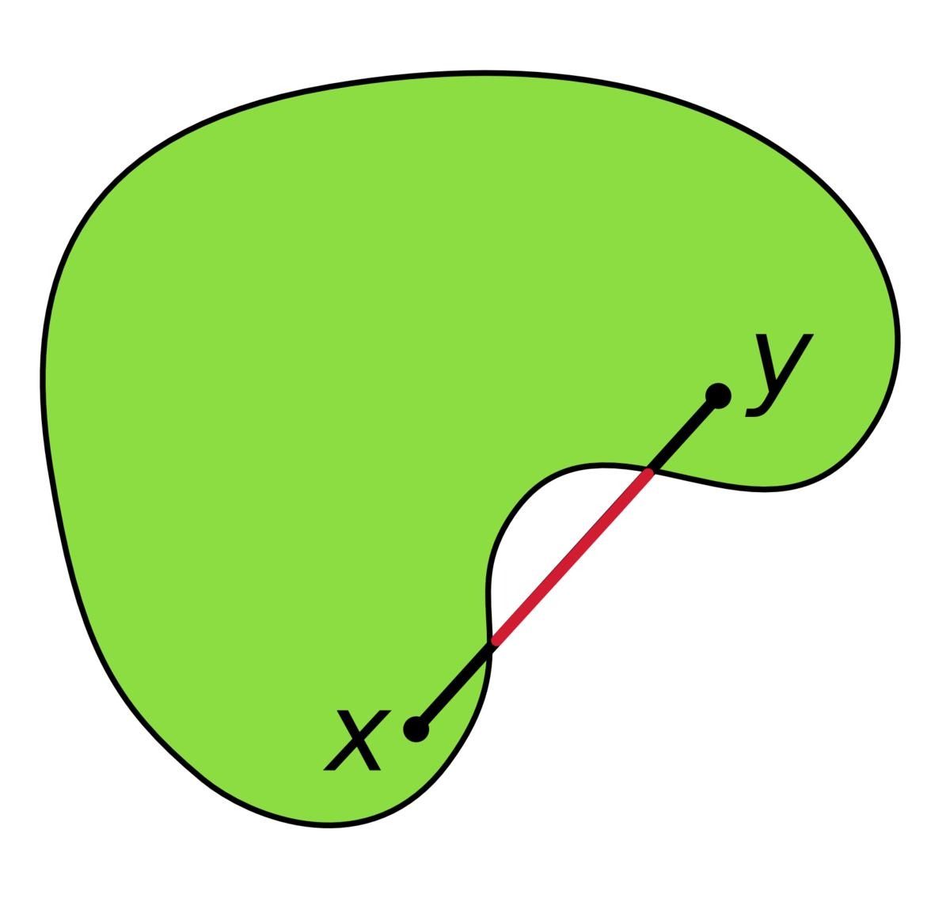
Non-Convex Solid
Fails test
At least one connecting segment passes outside the solid.

Mathematical Properties
# Source: AI Source: Provided by: [Data Path: Persons Table -> ID Column: 1, Name_En Column: Motasem Essam] -> From: [ChatGPT] on [7/25/2026]
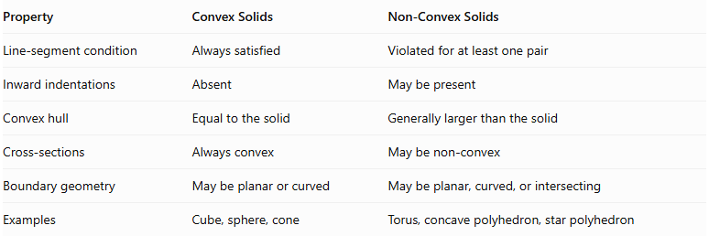
Property | Convex Solids | Non-Convex Solids
Line-segment condition | Always satisfied | Violated for at least one pair
Inward indentations | Absent | May be present
Convex hull | Equal to the solid | Generally larger than the solid
Cross-sections | Always convex | May be non-convex
Boundary geometry | May be planar or curved | May be planar, curved, or intersecting
Examples | Cube, sphere, cone | Torus, concave polyhedron, star polyhedron

Convex Hull
# Source: AI Source: Provided by: [Data Path: Persons Table -> ID Column: 1, Name_En Column: Motasem Essam] -> From: [ChatGPT] on [7/25/2026]
The Convex Hull of a solid is the smallest convex set that contains the entire solid.
It can be visualized as the smallest convex enclosure surrounding the solid.
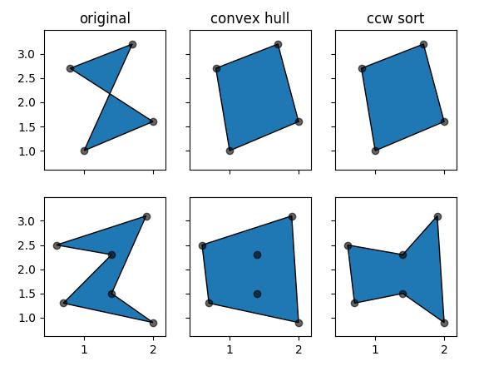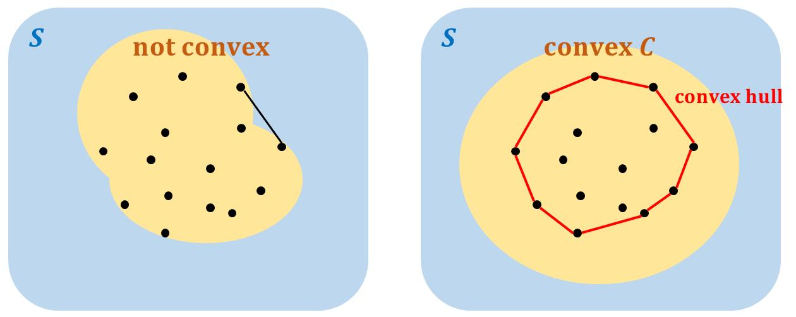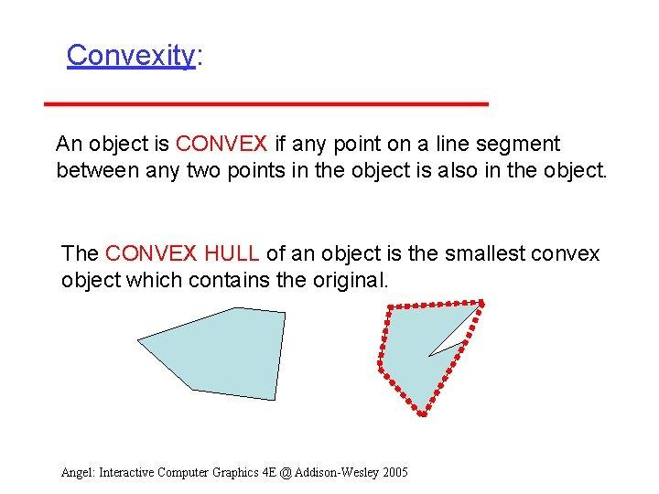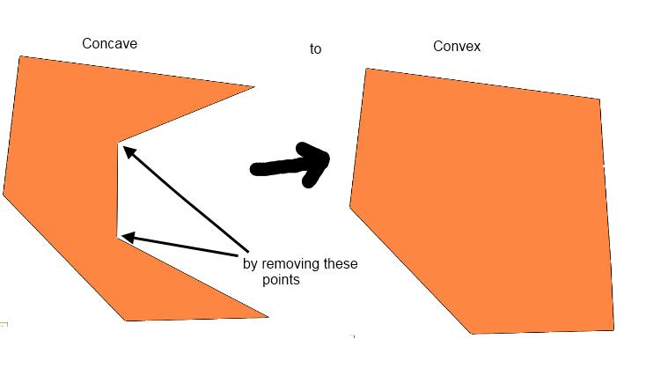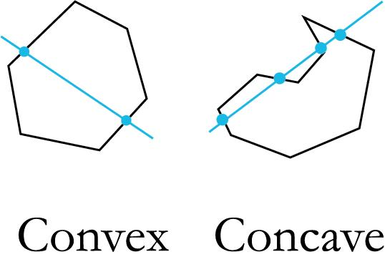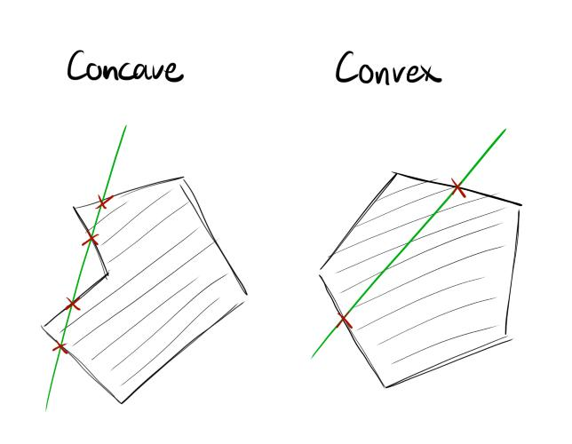
For a convex solid:
$$\boxed{Conv(S)=S}$$
For a non-convex solid:
$$\boxed{S⊊Conv(S)}$$
where $Conv(S)$ represents the convex hull of $S$.

Relationship to Other Geometric Classifications
# Source: AI Source: Provided by: [Data Path: Persons Table -> ID Column: 1, Name_En Column: Motasem Essam] -> From: [ChatGPT] on [7/25/2026]
Convexity is independent of several other geometric classifications.
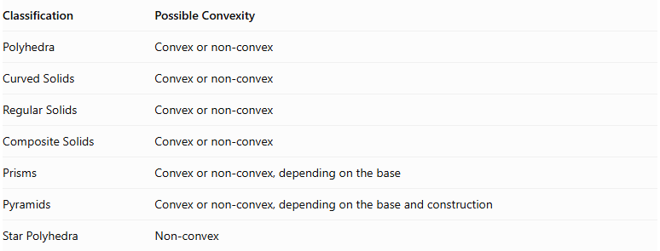
Classification | Possible Convexity
Polyhedra | Convex or non-convex
Curved Solids | Convex or non-convex
Regular Solids | Convex or non-convex
Composite Solids | Convex or non-convex
Prisms | Convex or non-convex, depending on the base
Pyramids | Convex or non-convex, depending on the base and construction
Star Polyhedra | Non-convex
Important distinction: A solid can be regular or irregular, polyhedral or curved, and still be classified independently according to its convexity.
For example, the Platonic solids are convex regular polyhedra, while the Kepler–Poinsot polyhedra are non-convex regular star polyhedra.

Main Classification
# Source: AI Source: Provided by: [Data Path: Persons Table -> ID Column: 1, Name_En Column: Motasem Essam] -> From: [ChatGPT] on [7/25/2026]
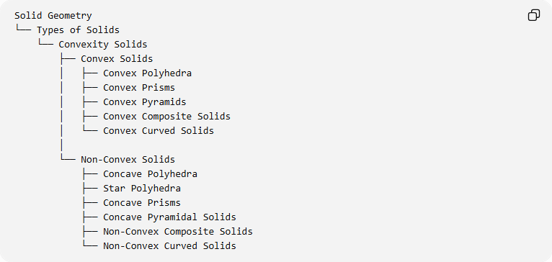
Solid Geometry
└── Types of Solids
└── Convexity Solids
├── Convex Solids
│ ├── Convex Polyhedra
│ ├── Convex Prisms
│ ├── Convex Pyramids
│ ├── Convex Composite Solids
│ └── Convex Curved Solids
│
└── Non-Convex Solids
├── Concave Polyhedra
├── Star Polyhedra
├── Concave Prisms
├── Concave Pyramidal Solids
├── Non-Convex Composite Solids
└── Non-Convex Curved Solids

Key Points
# Source: AI Source: Provided by: [Data Path: Persons Table -> ID Column: 1, Name_En Column: Motasem Essam] -> From: [ChatGPT] on [7/25/2026]
- Convexity is a geometric property used to classify three-dimensional solids.
- Convex solids contain every line segment connecting any two of their points.
- Non-convex solids have at least one connecting segment that passes outside the solid.
- Convexity applies to polyhedral and curved solids.
- Convex solids have a convex hull equal to themselves.
- Non-convex solids have a convex hull that generally contains additional space.
- The Platonic solids are examples of convex solids.
- The Kepler–Poinsot polyhedra are examples of non-convex solids.
- A solid's convexity is independent of whether it is regular, irregular, composite, or curved.

Conclusion
# Source: AI Source: Provided by: [Data Path: Persons Table -> ID Column: 1, Name_En Column: Motasem Essam] -> From: [ChatGPT] on [7/25/2026]
Convexity Solids provide a fundamental classification of three-dimensional geometry based on the spatial arrangement of points within a solid. The distinction between convex and non-convex solids applies across polyhedra, curved solids, and composite solids, making convexity an independent and broadly useful geometric classification.

